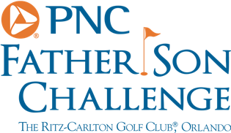
PNC Father Son Challenge – Preview
Jim Furyk
How special is it to be back here at the PNC Father Son Challenge for a second year?
“I think everyone has the same mentality here….it’s just fun to play with their sons or daughters or grandchildren. In the case of Annika and I, it would be our fathers. My dad got me started in the game, so I feel like he has been there every step of the way. When I’m on the course, I feel like he’s there with me, as my teacher. I hear his voice during my swings and all throughout the mental part of the game. So, to be out here with him and share a couple days on the golf course is great. My mom’s here for the pro-am fun and dinners is just a big deal. Last year, Tabitha and the kids were here. They will be here over the weekend this year.”
Would you say this is a unique event and really unlike anything else we see in the game of golf?
“The tournament is the vehicle, but in talking to the folks at PNC, it’s all about creating a nice family atmosphere. It’s important to their business, but is also special for the fans out here and at home to get to see it in person or on tv. I think the fans appreciate the human side. We have to have wonderful families to support us as we try to compete and travel as much as we do. So, it’s really nice to get to have a week for a change with them and share what we do.”
Do you ever see yourself playing with one of your kids in the event?
“My daughter plays a little, but not enough to be comfortable in this format. My son had quit for about five years, but picked it back up in the spring. He’s about ready to where he could come out here and do it with me. He’ll be 16 next month, so hopefully in the future, he and I will get a chance to play together in the event. “

