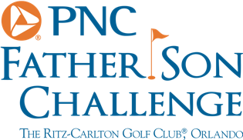
PNC Father Son Challenge – Preview
Gary Player and James Throssell
Welcome back, your first appearance in 17 years. What made you come back?
Gary: Entirely my grandson’s fault, I am pleased about it. He begged me to play, he said, I’ll even pay for my airfare, I said, alright we’ll go. Soon as I agreed, he said, no Gramps, you’ve got to pay, so here we are. He’s got one of my other grandsons caddying for him, my son is caddying for me. I’m looking forward to it. This event is one of the most enjoyable events you can play. To be able to play with your family and then also see players you grew up with for 50 years and see their children and grand children. It’s a blessing.
A real family affair then, you grew up playing with the legends you are teeing it up with this week, do you ever reminisce about the old days?
Gary: I do that all the time. If you respect and love the game, you do.

