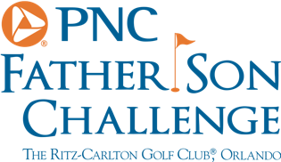
PNC Father Son Challenge – Round Two
Team Lehman
A birdie on the last, how big was that.
Tom Lehman: Very big, I think they will make birdie behind so we have at least given ourselves a chance.
How nice has it been to be paired with your son?
Tom Lehman: He played so well, he carried the team the first 14 holes then the old man came alive at the finish. He put me on his shoulders and carried us.
You’ve faced a putt to win a major, how was it facing a putt like that in this event?
There was pressure there, I did think this might be his last time he plays with me, who knows. I have younger sons so I wanted it to be a good one for him and he wanted it to be a good one for me, that’s really what the pressure of team golf is all about, the desire to make your partner happy.

