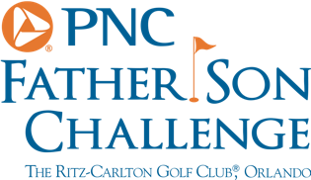
PNC Father Son Challenge – Round One
Team Sorenstam
First round in the books, how much did you enjoy that?
Annika: It was wonderful, I’m so proud of my dad. He stepped up when he needed to, I was a little nervous, I didn’t know what to expect but it was very enjoyable. Jim and his dad Mike could not have been any nicer.
Was there any on moment that will stick in your memory?
Annika: The first tee will stay in my memory, I was nervous for about three holes and you just don’t know how it is going to go. Our first birdie was kind of nice. Our goal was to do 6 under so we should be pleased with that.
Were you nervous for you or for your Dad?
Annika: I haven’t competed like this for a while and I knew I had to get him to the green so anything in between would be a bonus, I felt a bit of pressure in my long game and I just didn’t want to disappoint. I wanted him to enjoy this moment and not have awkward shots.

